Project Design Phase-II
Technology Stack (Architecture & Stack)

Date | 03 July 2026
Team ID
Project Name | Food Ordering Behaviour and Consumer Trends
Maximum Marks | 4 Marks

Technical Architecture:
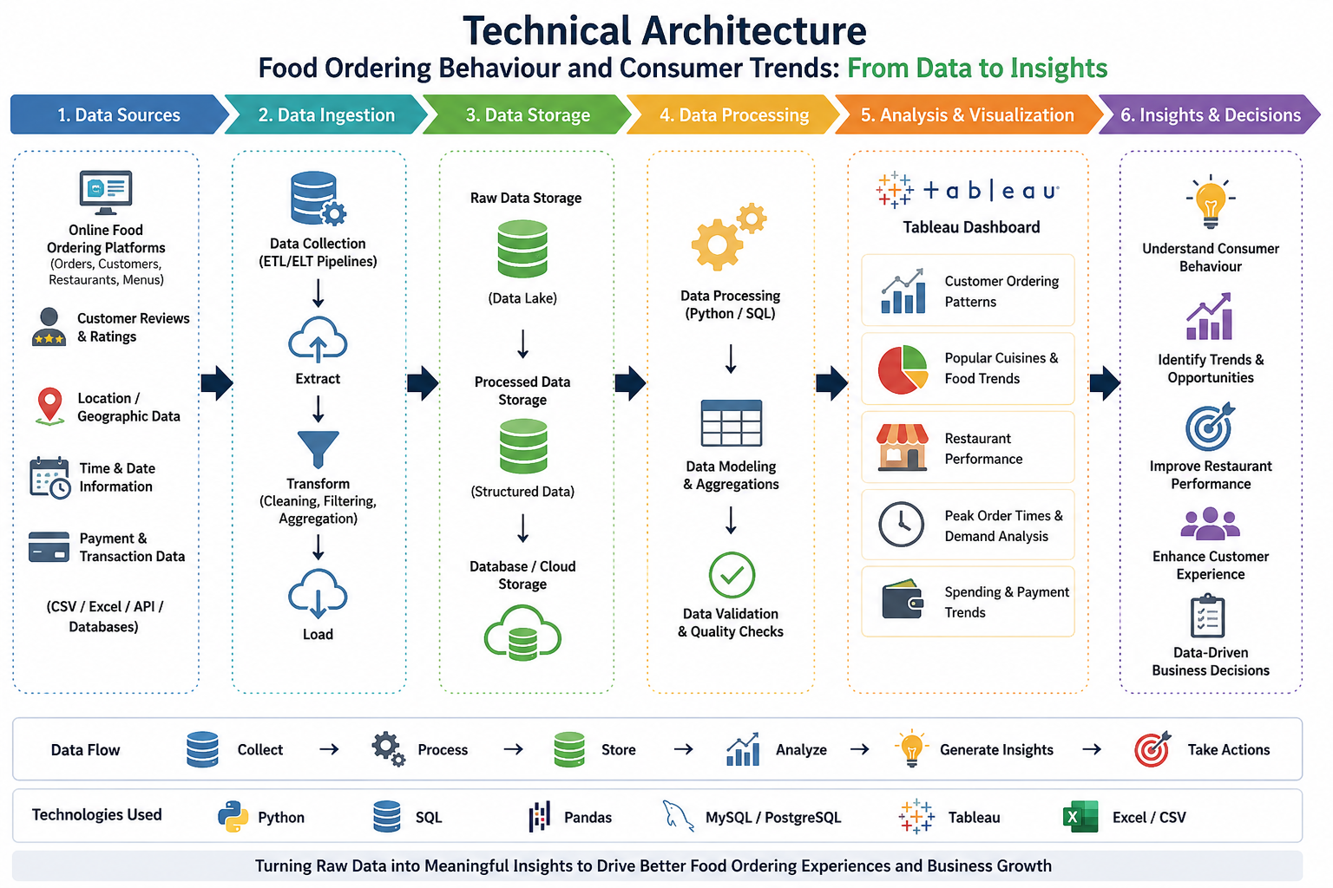

Table-1: Components & Technologies:
S. No | Component | Description | Technology
1 | Data Source | Collects food ordering data such as customer details, restaurants, orders, and ratings from CSV files. | CSV / Excel
2 | Data Preparation | Cleans, filters, and transforms raw data before analysis. | Tableau Prep / SQL
3 | Data Storage | Stores the processed and structured data for visualization. | CSV / MySQL
4 | Analytics & Visualization | Creates interactive charts, dashboards, and reports to analyse consumer behaviour and ordering trends. | Tableau
5 | Insights & Reporting | Generates business insights on popular cuisines, peak order times, customer preferences, and restaurant performance. | Tableau Dashboard
6 | Data Filtering | Enables users to filter data by city, cuisine, restaurant, order type, and date for detailed analysis. | Tableau Filters
7 | Dashboard & Reporting | Presents interactive dashboards and summary reports to support data-driven decision making. | Tableau Public / Tableau Desktop

Table-2: Application Characteristics:
S. No | Characteristics | Description | Technology
1 | Interactive Dashboard | Allows users to explore data using filters and visualizations. | Tableau
2 | Data Visualization | Displays trends using charts, graphs, and maps. | Tableau
3 | Data Analysis | Displays trends using charts, graphs, and maps. | Tableau Calculations / SQL
4 | Performance | Generates dashboards with fast loading and smooth interaction. | Tableau
5 | Scalability | Supports analysis of large datasets with additional records. | Tableau
6 | Data Accuracy | Ensures reliable and consistent insights from cleaned datasets. | Tableau Prep / SQL
7 | Reporting | Creates interactive reports for business decision-making. | Tableau Dashboard

